NEW HAVEN PORT AUTHORITY
REQUEST FOR PROPOSALS

To License Properties from the New Haven Port Authority in the New Haven Port District

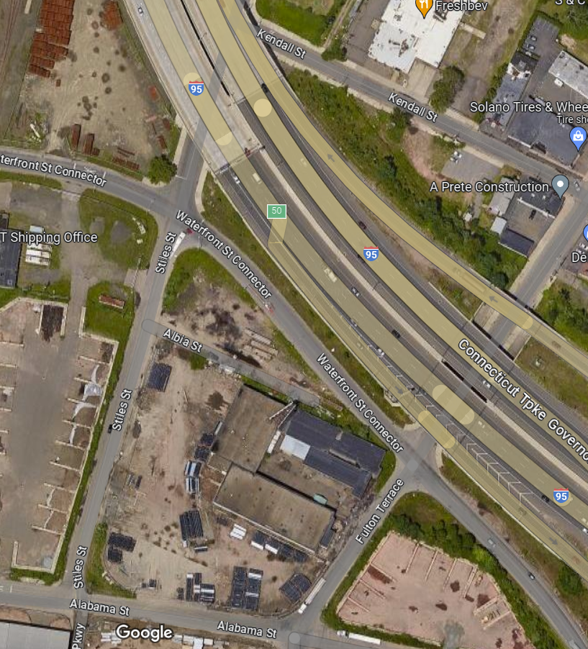

APRIL 2024 New Haven, CT

TABLE OF CONTENTS

Overview | Page 3
Background | Page 5
Properties Available to License through this RFP | Page 6
Licensing Agreement Provisions | Page 9
RFP Procedures and Communications | Page 14
RFP Requirements | Page 16
Other Matters | Page 17
Response Format | Page 18
Evaluation Criteria | Page 19
Successful Respondent(s) | Page 20
Notification of Award | Page 20
Respondent Information Cover Sheet and Certification | Page 21
Property Descriptions | Page 22
Maps | Page 28
Links to Relevant Documents | Page 32

Official Contact | Sally Kruse, Executive Director
 | New Haven Port Authority
 | P. O. Box 8716
 | New Haven, CT 06531
 | 203-946-6778
 | portauthority@newhavenct.gov

NEW HAVEN PORT AUTHORITY
REQUEST FOR PROPOSAL (RFP) TO LICENSE PROPERTIES IN THE PORT DISTRICT OF NEW HAVEN

OVERVIEW

The New Haven Port Authority (“NHPA”) is seeking parties to license and use four (4) properties located within the Port District of New Haven, CT (the “Parcels”), with uses that contribute positively to the growth of New Haven’s maritime economy and tax base Specifically, all the Parcels are located south of I-95 and the Q Bridge. The New Haven Port Authority was created by an ordinance (the “Ordinance”) of the City of New Haven to “…stimulate the shipment of freight and commerce through New Haven’s port, to develop and promote the facilities within the Port District and thereby to create jobs and increase the tax base of the City of New Haven, to work with the City of New Haven in maximizing the usefulness of available public funding by consolidating and coordinating efforts to assist the waterfront of the City of New Haven and to cooperate with the state and federal agencies in connection with the maintenance, development, improvement and use of the facilities within the port district.”

A 2007 Strategic Land Use Plan prepared for the NHPA identified as a primary undertaking of the NHPA to: “promote and encourage development of the port‐related economy; and maintain and expand maritime industrial employment and preserve and enhance key port properties for active maritime uses...” The NHPA has existing license agreements which state that the licensee is obliged to “use and occupy the Parcel(s) for the temporary storage of cargo transiting the Port of New Haven, (except that scrap cargoes are expressly prohibited without the express written approval of the NHPA) …". The respondents to this RFP should provide information regarding the specific use to which the Parcel(s) would be put and describe how such uses contribute to the multimodal movement of freight within the Port of New Haven and why the uses need to be located within the Port District.

NHPA is soliciting RFPs for licensing and use of Parcels 1, 3A/B, 4, and 5, which NHPA has acquired from the State of Connecticut (the “State”). License Agreements for Parcels will commence approximately at the end of the second quarter of 2024 or the beginning of the third quarter of 2024. Such uses must be in accordance with the goals outlined in the Ordinance and the Strategic Land Use Plan, namely, to expand New Haven’s tax base and create jobs within New Haven’s maritime sector. For this reason, additional consideration will be given to proposals that provide substantial support for these goals.

Parcel 4 will be licensed for a term ending 9/30/2029. For the other Parcels, in their responses to the RFP, Respondents are requested to provide the license term for which they wish to license the Parcel. The Parcels will be licensed “as is”, and NHPA will have no liability for existing environmental or other conditions. Respondents must agree to assume full responsibility for all actions required to achieve or maintain compliance with Environmental Laws (hereinafter defined) during the license term (the “License Term”). Environmental condition information that is available to NHPA for certain of the Parcels is listed for such Parcels and links are provided at the end of this RFP. The Port District is zoned IH (Heavy Industrial) and is in the VE (EL 16) FEMA Flood Hazard Zone. (Please note that the City of New Haven Flood Hazard regulations may be amended). Respondents are responsible for obtaining all zoning and land use permits and approvals required for their proposed uses on the Parcels.

Respondents may submit responses (which can be consolidated in one response) for one or more Parcels and are encouraged to submit responses on more than one Parcel.

Submission Deadline

All submissions are due by 4:00 p.m. EST May 20, 2024

BACKGROUND

The Port of New Haven
The Port of New Haven (the “Port”) is the second most active port in New England, second only to Boston and has the highest volume of commercial shipping in Long Island Sound. The Port serves a large portion of New England and is the busiest of Connecticut’s three deep-water ports.

The Port District
The Port District consists of 366 acres, not all of which are occupied by maritime-related businesses. The Port can currently accommodate ships ranging from 20,000 to 40,000 deadweight tons. It has ten berthing facilities at terminals ranging from 200 to 1,500 feet. There are approximately 250,000 square feet of indoor storage and 50 acres of outdoor storage within the Port District. The Port primarily handles petroleum products, chemicals, scrap metal, metallic products, cement, sand and stone, salt, and general breakbulk cargo. The Port’s fuel facilities are part of the U.S. Government’s strategic heating oil reserve. There has been a significant increase in rail traffic associated with the Port and indications are that rail movements in and out of the Port will continue to grow. In addition, $72 million has been appropriated to deepen the federal navigation channel in New Haven Harbor.

The NHPA and the Board of Commissioners

The Board of Commissioners of NHPA consists of seven (7) members appointed by the Mayor of New Haven and approved by the New Haven Board of Alders. The Commissioners serve for three (3) year terms and may be reappointed by the Mayor. Each Commissioner is required to serve until a replacement has been appointed. The Commissioners’ responsibilities are established by statute, City ordinance and bylaws adopted by the Board of Commissioners.

PROPERTIES AVAILABLE TO LICENSE THROUGH THIS RFP

Property | Size | Location
Parcel 1* | 1.49 acres | Northeast corner of Waterfront Street and the Waterfront Street Connector
Parcels 3A/B* | 1.022 acres | Southwest corner of Stiles Street and the Waterfront Street Connector
Parcel 4* | 0.293 acre | Southeast corner of Stiles Street and the Waterfront Street Connector
Parcel 5* | 0.898 acre | Southeast corner of Fulton Terrace and the Waterfront Street Connector
*Please note that the parcel numbers were assigned by the Connecticut Department of Transportation (“DOT”) during the Q Bridge improvement project.

Parcel 1

The first property, known as Parcel 1, is approximately 1.49 acres. It is located on the northeast corner of Waterfront Street and the Waterfront Street Connector. Specifically, the Parcel is located east of Waterfront Street, north of the Waterfront Street Connector, and south and west of eastbound I-95.

Parcel 1 is identified as "Release Area=6,032 ± m² (1.490 ± Acres)" on a map entitled " Town of New Haven, Map Showing Land Released to New Haven Port Authority by the State of Connecticut Department of Transportation, Waterfront Street @ Waterfront Connector, Scale 1:500, December 2016, Scott A. Hill, P.E., Chief Engineer–Bureau of Engineering and Construction, Town No. 92, Project No. 92-43, Serial No. 50F, Sheet 1 of 1", revised February 27, 2023. The Parcel is subject to (i) a drainage right-of-way in favor of the State, (ii) an easement for the purposes of inspection, maintenance, rehabilitation, and future construction of bridge structures and supporting piers in favor of the State, and (iii) a pipeline easement in favor of Magellan Holdings, L.P., n/k/a Buckeye PT Terminals LP. The map of this parcel is included in this RFP.

The following environmental assessment information is available for Parcel 1:
- Anchor Engineering - Preliminary Site Evaluation - Parcel 1 - DOT File #92-43-50E- prepared for the Connecticut Port Authority - May 2019
- Eolas Phase 1 Environmental Site Assessment Report - Parcel 1 - DOT File #92-43-50E – prepared for NHPA - March 2022
- Eolas Phase 2 Subsurface Investigation Report –prepared for NHPA – September 2022

Links to these reports are provided in the final section of this RFP.

Parcel 3A/B

This Parcel consists of two contiguous parcels known as “Parcel 3A” and “Parcel 3B”; together the Parcels have an area of approximately 1.022 acres. The Parcel is located on the corner of Stiles Street and Waterfront Street Connector, one block east of the marine terminals located on Waterfront Street. Specifically, the property is located to the west of Stiles Street and south of the Waterfront Street Connector. It is bounded by the Waterfront Street Connector to the north, Stiles Street to the east and a DOT waste stockpile area to the east and south. Parcel 3A, itself, formerly formed part of the DOT waste stockpile area.

Parcel 3A has an area of approximately 0.83 acre and is identified as “Parcel A Release Area = 3,349.2 + m² (36,050 + Sq. Ft.)” on a map entitled “Town of New Haven, Map Showing Land Released to New Haven Port Authority by the State of Connecticut Department of Transportation, Reconstruction of I-95 over West River New Haven-West Haven, Scale 1:500, July 2021, Scott A. Hill, P.E. Chief Engineer – Bureau of Engineering and Construction, Town No. 92, Project No. 92-522, Serial No. 14A, Sheet 1 of 1”, revised July 26, 2021, and March 1, 2023. The Parcel is subject to (i) an easement for existing utilities in favor of the State, and (ii) an easement for a sewer lateral in favor of the State. This map is included in this RFP.

Parcel 3B has an area of approximately 0.192 acre and is identified as "Parcel B Release Area=777.9 ± m² (8,373 ± Sq. Ft.)" on a map entitled " Town of New Haven, Map Showing Land Released to New Haven Port Authority by the State of Connecticut Department of Transportation, Reconstruction of I-95 over West River New Haven-West Haven, Scale 1:500, July 2021, Scott A. Hill, P.E., Chief Engineer–Bureau of Engineering and Construction, Town 92, Project No. 92-522, Serial No. 14A, Sheet 1 of 1”, revised July 26, 2021, and March 1, 2023. The Parcel is subject to (i) an easement for existing utilities in favor of the State and (ii) an easement for sewer lateral in favor of the State. This map is included in this RFP.

NHPA has no information regarding environmental conditions on this combined Parcel but notes that Parcel 3A was used by DOT as a waste storage area.

Parcel 4

The third Parcel, known as Parcel 4, has an area of approximately 0.293 acres. It is bounded by the present Albia Street to the south, Stiles Street to the west, and the Waterfront Street Connector to the northeast.

Parcel 4 is identified as "Release Area=1184.9 ± m² (12,754 ± Sq. Ft.)" on a map entitled " Town of New Haven, Map Showing Land Released to New Haven Port Authority by the State of Connecticut Department of Transportation, Waterfront Connector @ Stiles Street, Scale 1:500, August 2015, Scott A. Hill, P.E., Chief Engineer–Bureau of Engineering and Construction, Town No. 92, Project No. 92-532, Serial No. 34A, Sheet 1 of 1", revised June 8, 2016, and February 27, 2023. The map of this Parcel is included in this RFP.

The following environmental assessment information is available for the property:
- Anchor Engineering - Preliminary Site Evaluation - Parcel 4 - DOT File #92-43-34A – prepared for the Connecticut Port Authority – May 2019
- Eolas Phase 1 Environmental Site Assessment Report – Parcel 4 - DOT File #92-43-34A - prepared for the NHPA – March 2022
- Eolas Phase 2 Subsurface Investigation Report – Parcel 4 - prepared for NHPA – September 2022

Links to these reports are provided in the final section of this RFP.

Parcel 5

The fourth Parcel known as Parcel 5, has an area of approximately 0.898 acres. It is bounded by Alabama Street to the south, Fulton Terrace to the northwest, the Waterfront Street Connector to the northeast, and land owned by the State to the southeast.

Parcel 5 is identified as "Release Area=3637.2 ± m² (39,152 ± Sq. Ft.)" on a map entitled " Town of New Haven, Map Showing Land Released to New Haven Port Authority by the State of Connecticut Department of Transportation, Waterfront Connector (S.R. 921), Scale 1:500, August 2018, Scott A. Hill, P.E., Chief Engineer–Bureau of Engineering and Construction, Town No. 92, Project No. 92-532, Serial No. 11B, Sheet 1 of 1", revised February 27, 2023. Parcel 5 is subject to a drainage right-of-way in favor of the State. This map is included in this RFP.

Please note that the City of New Haven utilized the property as a waste storage area for the Downtown Crossing Project’s Phase 2/3 between 2020 and 2022. Two property condition reports can be found in the final section of this RFP.

The following environmental assessment information is available for the property:
- Anchor Engineering - Preliminary Site Evaluation - Parcel 5 - DOT File #92-43-11B – prepared for the Connecticut Port Authority – May 2019
- LES Subsurface Site Investigation Report – WSA pre-existing conditions report – Parcel 5 – prepared for the City of New Haven by Logical Environmental Solutions in March 2020
- Eolas Phase 1 Environmental Site Assessment Report – Parcel 5 - DOT File #92-43-11B - prepared for the NHPA – March 2022
- LES Subsurface Site Investigation Report – WSA Post-project conditions report – Parcel 5 – prepared for the City of New Haven by Logical Environmental Solutions in August 2022 and updated May 2023

Links to these reports are provided in the final section of this RFP.

LICENSING AGREEMENT PROVISIONS

The successful respondent(s) will be required to enter into a license agreement (the “License Agreement”) with the NHPA. The License Agreement will include among other matters, the following requirements, which may be stated in different language in the final License Agreement:

A “As Is” Condition

The Parcel(s) will be licensed in their “AS IS" CONDITION ON THE DATE OF EXECUTION OF THE LICENSE AGREEMENT WITH ALL FAULTS AND DEFECTS AND WITHOUT RECOURSE TO THE NHPA”. The successful respondent(s) will be required to agree, acknowledge, and stipulate that It has examined and is fully familiar with the condition of the Parcel(s) and all available environmental information. The successful respondent(s) will be required to acknowledge that it shall not be entitled to, and does not and will not, rely on NHPA or its agents as to (i) the quality, nature, adequacy or physical condition of the Parcel(s); (ii) the quality, nature, adequacy or physical condition of soils or ground water at the Parcel(s), (iii) the existence, quality, nature, adequacy or physical condition of the utilities serving the Parcel(s); (iv) the development potential of the Parcel(s) for any particular purpose; (v) the zoning or other legal status of the Parcel(s); (vi) the Parcel(s)’ compliance with any applicable codes, laws, regulations, statutes, ordinances, covenants, conditions or restrictions of any governmental or quasi-governmental entity or of any other person or entity, or compliance with or satisfaction of the Connecticut Department of Energy and Environmental (“DEEP”) orders; (vii) the presence of any underground or aboveground tanks, pits, sumps, drums or other containers; and/or (vii) the existence or nature of any Hazardous Materials, as hereinafter defined.
THE LICENSE AGREEMENT WILL CONTAIN AN ACKNOWLEDGMENT THAT THE SUCCESSFUL RESPONDENT HAS RELIED AND WILL BE RELYING ON ITS OWN DUE DILIGENCE REVIEW IN LICENSING THE PARCEL(S), INCLUDING PHYSICAL INSPECTIONS OF THE PARCEL(S), AND THAT THE PARCEL(S) ARE BEING LICENSED SOLELY IN RELIANCE UPON SUCH DUE DILIGENCE REVIEW, AND NO REPRESENTATIONS OR WARRANTIES, EXPRESSED OR IMPLIED HAVE BEEN MADE OR WILL BE MADE BY OR ON BEHALF OF NHPA WITH RESPECT TO THE PARCEL(S) OR THEIR PHYSICAL CONDITIONS.. Without limiting the generality of the foregoing, in the event of any defect or deficiency in the Parcel(s), whether latent or patent, NHPA shall not have any responsibility or liability with respect thereto, nor any liability for incidental or consequential damages. Upon execution of the License Agreement, the successful respondent shall be deemed to have waived, released and discharged any claims it has, might have or may in the future have against NHPA, NHPA’s officers, commissioners, directors, board members, employees or agents, any affiliate of NHPA, insurance companies and each of their respective successors and assigns (collectively, the “Released Parties”) , with respect to the condition of the Parcel(s), either patent or latent, the ability or inability to use or conduct operations on the Parcel(s), compliance with any Environmental Laws, including without limitation DEEP orders, and any other state of facts which may exist with respect to the Parcel(s). Furthermore, by executing the License Agreement, the successful respondent, on behalf of itself and its officers, directors, employees, agents, heirs, successors and assigns will fully and completely release, and discharge the Released Parties, and each of them, who may be liable to the successful respondent or the assigns, executors, successors, and administrators of the successful respondent from any and all claims, rights, actions, causes of action, demands, payments, attorneys’ fees, benefits, damages, costs, cleanup and removal costs, expenses, natural resource damages, and compensation whatsoever (collectively, the "Claims") which the successful respondent has or which may hereafter accrue arising from the licensing of the Parcel(s) or operations on the Parcel(s) and/or from any and all claims, rights and actions relating to the Parcel(s), irrespective of any action, inaction or negligence of any of the Released Parties, including but not limited to the following: (A) direct claims, third-party claims, and/or contribution actions for cleanup and removal costs and natural resource damages under Environmental Laws or at common law, other laws or in equity; and (B) claims (including by government agencies) or toxic tort claims arising out of any Hazardous Substances or Releases (hereinafter defined) discharged, released, disposed of, or stored at the Parcel(s) The successful respondent will agree in the Licensing Agreement not to institute, prosecute, facilitate or, absent a court order or other binding court process, assist in the institution or prosecution of any action, claim, proceeding or suit against any of the Released Parties, directly or indirectly, arising from or out of, or in connection with, any Claim arising out of any Environmental Law or environmental conditions on, at, under or from the Parcel(s), whether such environmental conditions existed or occurred prior to or after the execution or the effective date, if earlier than the execution of the License Agreement and regardless of whether such conditions were caused by the acts or omissions of the Released Parties or by third parties.

B. Rights of Easement Holders
The License Agreement for certain of the Parcel(s) will be subject to certain above ground and below ground easements and rights as indicated in this RFP, including, but not limited to, rights of access and subsurface use presently held by the easement holders.
C. Right to Construct Improvements
NHPA’s prior written consent will be required for the successful respondent to construct or erect any structural or other improvements on the Parcel(s), which consent may be withheld in the sole discretion of the NHPA.
- License Terms
- Parcels 1, 3A/B, and 5
The terms of the License Agreements for Parcels 1, 3A/B, and 5 shall be proposed by the respondents in their responses to the RFP.
2. Parcel 4
The term of the Licenses Agreement for Parcel 4 shall be for a term of approximately five (5) years, specifically ending on 09/30/2029.
- License Fees.
The license fees payable by the successful respondent during each year of the License Agreement (the "License Fee") shall be paid in twelve equal monthly installments in advance on the first (1st) day of each month during each year of the License Term, including any extensions thereof. The respondent shall propose the License Fee(s) to be paid in their responses to the RFP. Respondents should propose License Fees for the License Term, including any extensions thereof and any increases in the License Fees, (specifying the timing and amounts of such increases). Such proposal shall include at minimum increases calculated based upon the consumer price index for each year of the license term following the first year of the license term.

- Insurance and Indemnity.
- In addition to the indemnification obligations set forth in sections H.2(iv) and H.4. below, the successful respondent will indemnify, defend and hold harmless the Indemnified Parties, as hereinafter defined, against and from all losses, expenses, judgments, penalties, fines, damages, attorney's fees, claims, lawsuits, administrative notices, orders or proceedings, or demands of any nature arising in connection with successful respondent’s use and operations at the Parcel(s).
- The successful respondent shall, at the successful respondent’s sole cost and expense, obtain insurance policies covering all the successful respondent’s operations under the License Agreement, with general liability insurance in an amount of not less than Five Million and 00/100 ($5,000,000.00) Dollars, automobile coverage of not less than One Million and 00/100 ($1,000,000.00) Dollars and worker's compensation in the statutory amount. The successful respondent shall submit to NHPA a Certificate of Insurance with respect to such policies, showing NHPA as certificate holder and endorsements showing NHPA as an additional insured.
- Environmental Performance Requirements.
The successful respondent will comply with all Environmental Laws and will complete any environmental compliance requirements arising during the License Term, including any extensions of the initial term thereof, even if such requirements may extend beyond the end of the License Term.
  - For the purposes of the License Agreement, the following definitions shall apply:
    - "Hazardous Substance" means any material, pollutant, dangerous substance, toxic substance, hazardous chemical, solid waste, hazardous waste or any similar term, as defined in or pursuant to any applicable Environmental Laws, without regard to whether any substance shall have been deemed to be as hazardous at the time of its use, and shall specifically include any petroleum (or any fraction or constituent thereof), per- and polyfluoroalkyl substances (“PFAS”), asbestos and materials containing asbestos;
    - "Release" means any form of release of a substance on, at or from the Parcel(s) or emanating onto the Parcel(s), including spilling, leaking, seepage, pumping, pouring, emitting, emptying, discharging, ejecting, escaping, leaching, disposing, or dumping, as well as any definition of “release” set forth in Environmental Laws.
    - "Environmental Laws" under the License Agreement means any and all present or future federal, state, or local law, ordinance, regulation, rule, order, decision, or permit relating to the protection of the environment or of human health, including without limitation, the Comprehensive Environmental Response, Compensation and Liability Act, as amended, 42 U.S.C. § 9601, et seq., the Resource Conservation and Recovery Act, 42 U.S.C. § 6901, et seq., the Clean Air Act, 42 U.S.C. § 7401, et seq., the Clean Water Act, 33 U.S.C. § 1251, et seq., the Toxic Substance Control Act, 15 U.S.C. § 2601, et seq., the Occupational Safety and Health Act, 29 U.S.C. § 651, et seq., and Title 22a of the Connecticut General Statutes, and Title 32 of the Connecticut General Statutes Sections 32-760 et seq.,(hereinafter referred to as the "Brownfields Programs") and any regulations, implementing or referenced within said statutes, as any of the preceding have been amended prior to the effective date of the License Agreement.
  - Provisions Concerning Releases/Hazardous Substances
    - The successful respondent shall not generate, treat, store, dispose of, cause or permit any Release, or deposit of Hazardous Substances (as then currently classified) in or on the Parcel(s), including but not limited to any surface or sub-surface waters at the Parcel(s), except as permitted by law.
    - Neither the successful respondent nor any of its invitees shall undertake any activity at the Parcel(s) which would cause the Parcel(s) to become a hazardous waste treatment, storage, or disposal facility within the meaning of the Resource Conservation and Recovery Act of 1976 42 U.S.C. 6901 et. seq., as the same may be amended from time to time, or an Establishment as defined by the Connecticut Property Transfer Act (G.G.S. 22a-134 et seq.) nor shall the successful respondent cause or permit any invitees to cause a Release as defined by any Environmental Laws or cause the emission or discharge of any Hazardous Substances into the air or into any water source or system where any such emission or discharge would require a permit under any applicable Environmental Laws, without obtaining all applicable permits; and
    - The successful respondent shall not take any action with respect to any environmental condition, except in compliance with the requirements of all Environmental Laws and shall promptly notify NHPA as soon as practicable after the successful respondent becomes aware of any Release from or environmental condition on the Parcel(s) and shall promptly forward to NHPA copies of all orders, notices, permits, applications, documentation relating to compliance, and other communications and reports with or from any consultants and/or governmental body or agency in connection with any matter relating to Environmental Laws, to the extent that the Parcel(s) are affected, as soon as the successful respondent becomes aware of any such document.
    - In the event of any Release arising from the activities of the successful respondent, or its representatives, agents, invitees or contractors, the successful respondent shall, at its sole cost and expense, take such steps required by Environmental Laws and/or deemed necessary and/or appropriate by NHPA to address, remediate, and/or cleanup said Release. In the event that the successful respondent shall fail timely to undertake and complete such actions to address, remediate, and/or clean up the Release as soon as possible, NHPA and/or its agents or contractors may, but shall not be required to, enter the Parcel(s) to address the Release and shall be indemnified by the successful respondent for any loss, liability, damage, penalty, fine and expense, including (without limitation) reasonable attorney’s fees and disbursements that NHPA may incur.
  - Environmental Indemnification
The successful respondent shall indemnify and hold harmless NHPA and NHPA's officers, commissioners, board members, employees, agents, affiliates, successors, assigns, legal representatives, and insurers (the “Indemnified Parties”), against and from all loss, liability, damage, penalty, fine or expense, including (without limitation) reasonable attorney's fees and disbursements suffered or incurred by the Indemnified Parties, arising in connection with the creation or maintenance by the successful respondent or its employees, agents, vendors, or other invitees of any Release or environmental condition at the Parcel(s), or as a result of the successful respondent’s breach of any Environmental Laws or the failure of the successful respondent to comply with any of the successful respondent’s s obligations under the License Agreement, or arising in connection with any actions taken by any competent authority to enforce Environmental Laws, where any such loss, liability, damage, penalty, fine, or expense arises from the acts or omissions of the successful respondent occurring on or after the effective date of the License Agreement, including (without limitation) all costs and expenses arising (directly or indirectly) as a result of any Release, on, at or from the Parcel(s) caused by the successful respondent or its agents, employees, vendors, or invitees.
- Default.
In the event of any default or breach of the License Agreement by the successful respondent , NHPA shall deliver notice of such default or breach ("Default Notice") to the successful respondent and if the successful respondent does not cure the breach within ten (10) days with respect to any monetary obligation, or within a reasonable period of time not to exceed thirty (30) days with respect to any other obligation, agreement or covenant, then the License Agreement shall automatically terminate, and NHPA shall be permitted to immediately reenter the Parcel(s) and the License Agreement shall thereafter be null and void of no further effect. In such case, the successful respondent shall:
  - Immediately vacate the Parcel(s) and remove all of the successful respondent’s property located on the Parcel(s) at the successful respondent’s sole cost and expense; and
  - Continue to pay the monthly License Fee specified in the License Agreement until the end of the License Term, including any extension thereof which has been exercised, notwithstanding the earlier termination thereof resulting from the successful respondent’s default; which monthly License Fee shall be (i) reduced, however, by any monthly license fees NHPA may receive as a result of relicensing the Parcel(s); and (ii) increased by NHPA’s reasonable costs, expenses, brokerage fees and attorney's fees and any maintenance, repair and/or alteration of the Parcel(s), if any, it may incur with respect to such relicensing.
- NHPA Self-Help.
NHPA may without notice to tor demand upon the successful respondent and without waiving or releasing the successful respondent from any obligation of the successful respondent under the License Agreement, perform any other act that the successful respondent is required to perform under the License Agreement, and which the successful respondent has failed to perform. Any necessary and incidental costs and expenses incurred in connection with the performance of any such act by NHPA shall be deemed additional fees and sums payable to NHPA, and shall be payable to NHPA on demand or, at the option of the NHPA, may be added to any sums due or thereafter becoming due under the License Agreement.

RFP PROCEDURES AND COMMUNICATIONS

Official Contact | Sally Kruse, Executive Director
 | New Haven Port Authority
 | P. O. Box 8716
 | New Haven, CT 06531
 | 203-946-6778
 | portauthority@newhavenct.gov

There will be a respondent walkthrough at 3:00 p.m. on May 6, 2024, meeting on the corner of Alabama Street and Fulton Terrace. Additional walkthroughs may be granted upon request, but NHPA reserves the right not to provide additional walkthroughs at its sole discretion.
The respondents shall submit responses by 4:00 p.m. EST on May 20, 2024
- One original signed proposal together with one (1) additional copy via U.S. mail and one (1) electronic copy to the New Haven Port Authority.at newhavenportauthority@newhavenct.gov
Questions or clarifications regarding this RFP should be directed by email to Executive Director, New Haven Port Authority at portauthority@newhavenct.gov and will be responded to in the form of addenda. If addenda are issued, all repondents will be notified via email. To ensure that all addenda are received, please contact the New Haven Port Authority at the above email address immediately upon deciding to respond and provide the appropriate contact email.

The responses should be provided in the format found on page 18.

Communicating with the NHPA
- All inquiries and communications with NHPA regarding this RFP must be directed in writing to Executive Director, New Haven Port Authority via email at the address stated above. All other communications with NHPA, with any person representing NHPA or with the City, including its Commissioners, officials and employees and representatives, are prohibited. Any violation of this prohibition by respondents or their representatives concerning this RFP may result in disqualification.
- NHPA reserves the right to alter, modify, amend, or revoke this RFP, including but not limited to modifying requirements for respondents and modifying services to be provided to NHPA and will do so in the form of one or more addenda, which will be communicated with all respondents.
- All submissions must be submitted before the deadline, be complete, and be signed by the preparer, who is authorized to do so on behalf of the respondent. NHPA, at its sole discretion, may disqualify any proposal that fails to meet these requirements.
- If a respondent discovers an error in its submission prior to the response submission deadline, the respondent may request in writing that the submission be withdrawn. Such a request must be signed by an authorized representative of the respondent If the request is approved, the respondent may submit a revised response, if such revised response is received prior to the response submission deadline.
- No alterations or corrections to the responses are permitted after the responses have been opened by NHPA. If an error is discovered after the response is opened by NHPA, but before a decision is made on the request for proposals, the respondent may request in writing that its response be withdrawn. Such a request must be signed by an officer or authorized representative of the respondent. The decision to permit withdrawal of the response will be at the sole discretion of the NHPA.
- NHPA reserves the right to ask for clarification of any responses to this RFP and to request additional information from a respondent and the failure to provide such clarification or information could result in the rejection of a response to this RFP.
- Any respondent, if requested, must be prepared to present evidence of experience, ability, capacity to perform, and financial standing.
- NHPA reserves the right to waive any informalities in the responses received.
- All costs for the preparation and presentation of the response to this RFP and all costs incurred with respect to the negotiation of the License Agreement between the successful respondent(s) and NHPA shall be the sole responsibility of the respondent.
- Changes to Proposal. Except as otherwise permitted by the NHPA, no additions or changes to a proposal will be allowed after submittal.
- Collusion. By responding, the respondent implicitly states that its proposal is not made in connection with any competing respondent submitting a separate response to this RFP and is in all respects fair and without collusion or fraud. It is further implied that the respondent did not participate in the RFP development process, had no knowledge of the specific contents of the RFP prior to its issuance, and that no Commissioners or employees of the NHPA participated directly or indirectly in the respondent's proposal preparation.

RFP REQUIREMENTS

All respondents should provide the following information:
- Respondent information:
    - Contact Information, including email address.
    - Whether the respondent is authorized to do business in the State of Connecticut and respondent’s registration with the Connecticut Secretary of State
    - Respondent’s background including history performing activities similar to those proposed on the Parcels,
    - Financial statements for the last two calendar or fiscal years and/or other evidence of financial ability to perform under the License Agreement for the Parcel(s),
    - The names of respondent’s principals and any affiliated companies (any companies controlled by respondent or under common control with the respondent) and the nature of the businesses that they conduct.
    - A description of any similar leases or license agreements that the respondent or its affiliated companies have entered into, including contact information for the lessor or licensor and activities conducted pursuant to the lease or license agreement,
    - Past or present contracts or agreements with the NHPA, the City of New Haven, or the Connecticut Port Authority,
    - Respondents should state whether they or their affiliated companies have ever been found to have violated any municipal, state or federal regulation or law or whether there are any pending claims, notices of violation, administrative actions, or charges for violations against respondents or their affiliated companies.
    - Respondents should state whether they, their principals or their affiliated companies are subject to trade restrictions under the USA Patriot Act (50 U.S.C 1 et seq.) or any Executive Orders promulgated thereunder (Embargoed Persons), such that any contract with respondents or their affiliated companies is prohibited by law.
    - Respondents should state whether they, their principals or their affiliated companies have been suspended or debarred from participating in any federal, state, municipal, or local contract.

- Respondents should identify the proposed use(s) for the Parcel(s) and should address how the proposed use(s) relates to and furthers maritime commerce within the Port of New Haven.
- Respondents should propose the License Term, including any options to extend the term.
- Respondents should propose License Fees for the License Term, including any extensions thereof and any increases in the License Fees, (specifying the timing and amounts of such increases). Such proposal shall include at minimum increases calculated based upon the consumer price index for each year of the license term following the first year of the license term.
- Respondents should indicate if they plan to construct any improvements on the Parcel(s), and if so, respondents should describe the nature and extent of such improvements, the anticipated costs of construction of the improvements and value of the improvements, the financing sources for the improvements, the estimated time and a proposed schedule for construction, and the number of construction jobs anticipated to be created.
- Respondents should state the number and types of jobs that their occupancy of the Parcel(s) is anticipated to generate.
- Respondents should state how their occupancy of the Parcel(s) will grow the City of New Haven’s tax base.
- Respondents should state whether they will be providing any guaranty for their obligations under the License Agreement.
- Respondents should provide three references, including two references from previous landlords/lessors, port authorities or governmental entities.
- Please complete the Respondent Information Cover Sheet and Certification form found on the final page of this RFP.
- EEO-4 Form. The proposal shall include a copy of respondent’s latest equal opportunity policy.

OTHER MATTERS
- Ownership of Proposals. All materials submitted by respondents in response to this RFP shall be considered public information after any successful respondent is selected in accordance with the Connecticut Freedom of Information Act, Conn. Gen. Stat. Sec. 1-200 et seq. Any confidential information should be marked as “confidential”. All proposals in response to this RFP will be the sole property of the NHPA.

- Oral Agreements. No license agreement or any other agreement, unless it shall be in writing, executed by an authorized representative of the NHPA following the obtaining of all necessary approvals and in accordance with all applicable law, shall be binding on the NHPA. No oral agreement or arrangement made with the NHPA or any NHPA Commissioners or employees shall be binding on the NHPA.

RESPONSE FORMAT

NHPA requests that responses be submitted in the following format:
- Respondent Information Cover Sheet and Certification form.
- Introduction containing:
  - Respondent’s information from page 16 of this RFP
  - Respondent’s registration with Connecticut Secretary of State and authorization to do business in Connecticut.
  - Respondent’s references
  - Financial and Guaranty information.
  - Past or present assignments, relationships, or other employment that Respondent has or has had with NHPA, the City of New Hven or the Connecticut Port Authority.
  - Any actual or potential conflicts of interest in providing requested services.
  - Respondent’s contact information
- Use of Parcel(s) License Fees and License Term:
  - Proposed License Fees, including proposed increases.
  - Proposed uses of the Parcel(s)
  - Proposed modifications or improvements proposed for the Parcel(s)
  - Proposed License Term
  - The number and types of jobs occupancy is expected to generate.
  - How occupancy of parcels will increase the tax base of the City of New Haven.
- EEO-4 Form.
  - Respondent’s latest equal opportunity policy
NHPA reserves the right to consider responses that are not in this format, but failure to follow this format may make responses more difficult to evaluate and potentially obscure the merits of a response.

EVALUATION CRITERIA

Following receipt of the responses to the RFPs, the responses will be reviewed, and several respondents may be interviewed prior to selection

The responses will be evaluated by the Board of Commissioners on the basis of the following criteria
- Specific proposed use of the Parcel(s), including reasons proposed use should be located within the Port rather than elsewhere, and how the proposed use(s) of the Parcel(s) relates to maritime commerce in the Port and/or the multimodal movement of freight, emphasizing how the use(s) furthers the NHPA’s goals.
- License Fee(s), including proposed increases.
- License Term(s), including proposed extensions,
- References, including those of former lessors, licensors or port authorities.
- Experience in undertaking the uses proposed for the Parcel(s)
- Financial ability to perform obligations under the License Agreement
- Jobs and taxes to be generated by the use of the Parcel(s)
- Improvements to be made to the Parcel(s)
Proposals are subject to potential rejection in whole or in part if they limit or modify any of the terms, conditions and/or specifications of this RFP. NHPA reserves the right to accept or reject any or all of the proposals submitted for consideration under this RFP and reserves the right, in its sole discretion, not to award a license agreement to any of the respondents.. NHPA reserves the right to reject any proposal if any proposed respondent is in default of any prior contract with the NHPA, the City of New Haven or the Connecticut Port Authority or for any misrepresentation. NHPA also reserves the right, in its sole discretion, not to award a License Agreement to a particular respondent.

SUCCESSFUL RESPONDENT(S)

- Following selection of the successful respondent(s), NHPA will present the successful respondent(s) with a proposed License Agreement. Where the terms of a License Agreement cannot be agreed upon between the successful respondent(s) and NHPA, NHPA reserves the right or select another respondent or re-issue a request for proposal to license any or all of the Parcels, at its sole discretion.
- NHPA also intends to add terms to the License Agreement that are not set forth in this RFP and may modify the terms that are described in this RFP.
- The License Agreement shall require the successful respondent(s) to honor the financial terms and the license term set forth in its response to this RFP, unless a change is approved by the NHPA and to abide by its schedule for constructing any improvements as set forth in its response to this RFP, unless modifications are approved by NHPA.
- Clerical Errors in Awards. The NHPA reserves the right to correct inaccurate awards resulting from its clerical errors.
- The License Agreement to be entered into by the NHPA and the respondent may not be sublicensed or assigned by the respondent, in whole or in part, without prior written consent of the NHPA, which may be withheld in its sole discretion. Such consent, if granted, shall not relieve the respondent of its responsibilities under the License Agreement , except as otherwise expressly provided therein.

NOTIFICATION OF AWARD

The successful respondent(s), if any, will receive a Notice of Award. The Notice may contain certain contingency requirements that must be satisfied within a designated time frame. Failure to comply with all provisions of the Notice of Award may disqualify that respondent, and the award may be directed to another respondent.

RESPONDENT INFORMATION COVER SHEET AND CERTIFICATION

Respondent Information:

Name:
Address:
Contact Person:
Title:
Telephone Number:
Email Address: | Website Address:
FEIN No.: | State Sales Tax No:

Respondent Certification:

It is hereby represented by the respondent (undersigned) that to the best of my knowledge and belief, all information or data contained in the proposal or in the attachments are true and correct and that no material information has been omitted. It is also positively certified that the conditions of this RFP have been adhered to in this proposal.
Certifying Representative:
Name and Title (typed or printed): _________________________________________________
Signature: _____________________________________________________________________
Date: ______________________________________

PROPERTY DESCRIPTIONS

Parcel 1 Legal Description
That certain parcel of land, identified in this deed as the first parcel, containing 6,032 square meters, more or less (1.490 acres, more or less), situated in the Town of New Haven, County of New Haven, and State of Connecticut, located on the northerly side of Present Waterfront Connector, and more particularly shown on a map filed in the New Haven Town Clerk’s Office entitled: “TOWN OF NEW HAVEN MAP SHOWING LAND RELEASED TO NEW HAVEN PORT AUTHORITY BY THE STATE OF CONNECTICUT DEPARTMENT OF TRANSPORTATION WATERFRONT STREET @ WATERFRONT CONNECTOR SCALE 1: 500 DECEMBER 2016 SCOTT A. HILL, P.E. CHIEF ENGINEER – BUREAU OF ENGINEERING AND CONSTRUCTION”, TOWN NO. 92, PROJECT NO. 92-43, SERIAL NO. 50F, SHEET 1 OF 1. Revised 2/27/23 and bounded and described as follows:
SOUTHERLY by Present Waterfront Connector, a total distance of 89.2 meters, more or less, (293 feet, more or less), by a line designated “RELEASE LINE & PROPOSED STREET LINE”, as shown on said map;
WESTERLY by land of the State of Connecticut (D.O.T.), a total distance of 134.6 meters, more or less, (442 feet, more or less), by a line designated “RELEASE LINE”, as shown on said map;
NORTHEASTERLY by I-95 Northbound, a distance of 144.8 meters, more or less, (475 feet, more or less), by a line designated “RELEASE LINE& PROPOSED NONACCESS HIGHWAY LINE”, as shown on said map;
EASTERLY by Present Stiles Street at the intersection of Present Waterfront Connector, a distance of 17.1 meters, more or less, (56 feet, more or less), by a line designated “RELEASE LINE & STREET LINE”, as shown on said map.
For the Grantor’s source of title to this parcel, reference is made to acquisitions by the State of Connecticut from T.A.D. Jones and Company, Incorporated, as contained in a Quit-Claim Deed dated October 16, 1964 and recorded in Volume 2256 at Page 265 of the New Haven Land Records, through Eminent Domain proceedings against the City of New Haven, as evidenced by a Certificate of Condemnation filed on March 28, 1950 and recorded in Volume 1653 at Page 383 of the New Haven Land Records, against the New Haven Port Authority, as evidenced by a Certificate of Condemnation filed on February 26, 2019 and recorded in Volume 9820 at Page 249 of said Land Records, and against Ruth Caliendo, as evidenced by a Certificate of Condemnation filed on October 25, 2002 and recorded in Volume 6239 at Page 218 of said Land Records
Reserving unto the Grantor, its successors and assigns forever, a full and perpetual easement for the purposes of inspection, maintenance, rehabilitation and future construction of bridge structures and supporting piers, within an area of 1,420.3 square meters, more or less (15,285 square feet, more or less) under, over and across a portion of the land herein conveyed, as more particularly shown on said map.
Reserving unto the Grantor, its successors and assigns forever, a full and perpetual drainage right of way, within an area of 668.6 square meters, more or less (7,198 square feet, more or less), under over and across a portion of the land herein conveyed, as more particularly shown on said map.
And the Grantor further reserves unto itself its successors and assigns forever, a full and perpetual right and privilege to enter upon the said premises by its officers, employees, servants and agents, for the purpose of constructing, building, maintaining, cleaning, repairing, reconstructing and inspecting, at all times the facilities located within said drainage right of way, with appurtenances thereto, upon, over, under and across said easement area, together with the further right to flow water through said facilities.
Together with the release of all rights of access directly to and from the land herein conveyed, over and across the lines designated “RELEASE LINE & PROPOSED STREET LINE” AND “RELEASE LINE & STREET LINE”, formerly designated “NON-ACCESS HIGHWAY LINE”, as more particularly shown on said map.
All rights of Ingress and Egress are specifically denied, directly to and from I-95 Northbound and Present Waterfront Street, from and to the land herein conveyed, as more particularly shown on said map.
The above-described parcel is conveyed subject to such rights and easements as may appear of record, and to any state of facts which an inspection of the premises may show.
The above-described parcel is subject to any and all provisions of any ordinance, municipal regulation, or public or private law.

Parcel 3A Legal Description
That certain parcel of land, as “PARCEL A RELEASE AREA =3,349,2+m² (36,050+ SQ.FT.)”, situated in the Town of New Haven, County of New Haven, and State of Connecticut located on the northwesterly side of Present Stiles Street, and more particularly shown on a map filed in the New Haven Town Clerk's Office entitled: “TOWN OF NEW HAVEN MAP SHOWING LAND RELEASED TO NEW HAVEN PORT AUTHORITY BY THE STATE OF CONNECTICUT DEPARTMENT OF TRANSPORTATION RECONSTRUCTION OF 1-95 OVER WEST RIVER NEW HAVEN-WEST HAVEN SCALE 1:500 JULY 2021 SCOTT A. HILL, P.E. CHIEF ENGINEER – BUREAU OF ENGINEERING AND CONSTRUCTION”, TOWN NO. 92 PROJECT NO. 92, PROJECT NO. 92-522, SERIAL NO. 14A, SHEET 1 OF 1, Last revised 3/1/23 and, bounded and described as follows:
SOUTHEASTERLY by Present Stiles Street, a distance of 110.1 meters, more or less, (361 feet, more or less), by a line designated “RELASE LINE & STREET LINE”, as shown on said map;
WESTERLY by land of the State of Connecticut (DOT), a distance of 165.9 meters, more or less, (544 feet, more or less), by a line designated ‘RELASE LINE & PROPERTY LINE”, as shown on said map;
NORTHERLY by Present Waterfront Connector, a distance 11.5 meters, more or less, (38 feet, more or less), by a line designated ‘RELEASE LINE & PROPOSED STREET LINE (92-532-19A)”, as shown on said map;
NORTHEASTERLY by “Parcel B” and Present Stiles Street, each in part, a distance of 64.3 meters, more or less, (211 feet more or less), by lines designated ‘RELEASE LINE & FORMER NON-ACCESS HIGHWAY LINE” and “RELEASE LINE & PROPSED STREETLINE (92-532-19A”, as shown on said map.
For the State’s source of title to the premises, reference is made to an acquisition by the State of Connecticut through Eminent Domain proceedings against the New Haven Port Authority, as evidenced by a Certificate of Condemnation filed on February 26, 2019 and recorded in Volume 9820 at Page 249 of the New Haven Land Records.
Reserving unto the State of Connecticut, Department of Transportation, its successors and assigns forever, a full and perpetual easement for existing utilities, and a full and perpetual easement for sewer lateral within an area of 79.5 square meters, more of less (261 square feet, more or less) under, over and across a portion of the land herein conveyed, as more particularly shown on said map.
The above-described parcel is conveyed subject to such rights and easements as may appear of record, and to any state of facts which an inspection of the premises may show.
The above-described parcel is subject to any and all provisions of any ordinance, municipal regulation, or public or private law.

Parcel 3B Legal Description
That certain parcel of land, identified in this deed as the fifth parcel and on the below-referenced map as PARCEL B RELEASE AREA =777.9+m² (8,373+ SQ. FT), situated in the Town of New Haven, County of New Haven, and State of Connecticut, located on the southerly side of Present Waterfront Connector, and more particularly shown on a map filed in the New Haven Town Clerk's Office entitled "TOWN OF NEW HAVEN MAP SHOWING LAND RELEASED TO NEW HAVEN PORT AUTHORITY BY THE STATE OF CONNECTICUT DEPARTMENT OF TRANSPORTATION RECONSTRUCTION OF 1-95 OVER WEST RIVER NEW HAVEN-WEST HAVEN SCALE 1:500 JULY 2021 SCOTT A. HILL, P.E. CHIEF ENGINEER – BUREAU OF ENGINEERING AND CONSTRUCTION”, TOWN NO. 92, PROJECT NO. 92-522 SERIAL NO. 14A, SHEET 1 0F 1. Last revised 3/1/23 and bounded and described as follows:
NORTHERLY by Present Waterfront Connector, a distance of 35.3 meters, more or less (116 feet, more or less), by a line designated “RELEASE LINE & PROPOSED STREET LINE (PER 92-532-19A)”, as shown on said map,
NORTHEASTERLY by Present Stiles Street at the intersection of Present Waterfront Connector, a distance of 10.6 meters, more or less (35 feet, more or less), by a line designated “RELEASE LINE & PROPOSED STREET LINE (PER 92-532-19A)”, as shown on said map,
EASTERLY by said Present Stiles Street, a distance of 30.2 meters, more or less, (99 feet, more or less), by a line designated “RELEASE LINE & PROPOSED STREET LINE (PER 92-532-19A)”, as shown on said map,
SOUTHWESTERLY by Parcel “A”, a distance of 59.2 meters, more or less, (194 feet, more or less), by a line designated “RELEASE LINE & FORMER NON-ACCESS HIGHWAY LINE”, as shown on said map.
For the Grantor’s source of title to this parcel herein conveyed, reference is made to an acquisition by the State of Connecticut through Eminent Domain proceedings against the City of New Haven, as evidenced by a Certificate of Condemnation filed on March 28, 1950 and recorded in Volume 1653 at Page 383 of the New Haven Land Records.
Reserving unto the Grantor, its successors and assigns forever, a full and perpetual easement for existing utilities and a full and perpetual easement for sewer lateral, within an area of 6.7 square meters, more or less (22 square feet, more or less), under, over and across a portion of the land herein conveyed, as more particularly shown on said map.
The above-described parcel is conveyed subject to such rights and easements as may appear of record, and to any state of facts which an inspection of the premises may show.
The above-described parcel is subject to any and all provisions of any ordinance, municipal regulation, or public or private law.

Parcel 4 Legal Description
That certain parcel of land, identified in this deed as the second parcel, containing 1,184.9 square meters, more or less (12,754 square feet, more or less), situated in the Town of New Haven, County of New Haven, and State of Connecticut, located on the southwesterly side of Present Waterfront Connector, and more particularly shown on a map filed in the New Haven Town Clerk’s Office entitled: “TOWN OF NEW HAVEN MAP SHOWING LAND RELEASED TO NEW HAVEN PORT AUTHORITY BY THE STATE OF CONNECTICUT DEPARTMENT OF TRANSPORTATION WATERFRONT CONNECTOR @ STILES STREET SCALE 1: 500 AUGUST 2015 SCOTT A. HILL, P.E. CHIEF ENGINEER – BUREAU OF ENGINEERING AND CONSTRUCTION”, TOWN NO. 92, PROJECT NO. 92-532, SERIAL NO. 34A, SHEET 1 OF 1. Last revised 2/27/23 and bounded and described as follows:
NORTHEASTERLY by Present Waterfront Connector, a total distance of 73.3 meters, more or less, (240 feet, more or less), by a line designated “RELEASE LINE & PROPOSED STREET LINE”, as shown on said map;
SOUTHERLY by Present Albia Street, a distance of 73.2 meters, more or less, (240 feet, more or less), by a line designated “RELEASE LINE & STREET LINE”, as shown on said map;
WESTERLY by Present Stiles Street, a distance of 20.7 meters, more or less, (68 feet, more or less), by a line designated “RELEASE LINE & STREET LINE”, as shown on said map;
NORTHWESTERLY by the intersection of Present Stiles Street at Present Waterfront Connector, a distance of 11.5 meters, more or less, (38 feet, more or less), by a line designated “RELEASE LINE & PROPOSED STREET LINE”, as shown on said map. 3 of 6 New Haven Port Authority 92-43-50F
For the Grantor’s source of title to this parcel, reference is made to acquisitions by the State of Connecticut through Eminent Domain proceedings against Interplex Electronics Inc., as evidenced by a Certificate of Condemnation filed on September 27, 2002 and recorded in Volume 6218 at Page 157 of the New Haven Land Records, against Theresa L. D’Onofrio, as evidenced by a Certificate of Condemnation filed on December 6, 2002 and recorded in Volume 6276 at Page 066 of said Land Records, against Fred D’Onofrio, as evidenced by a Certificate of Condemnation filed on December 6, 2002 and recorded in Volume 6276 at Page 068 of said Land Records, and against the New Haven Port Authority, as evidenced by a Certificate of Condemnation filed on April 24, 2014 and recorded in Volume 9137 at Page 218 of said Land Records.
The above-described parcel is conveyed subject to such rights and easements as may appear of record, and to any state of facts which an inspection of the premises may show.
The above-described parcel is subject to any and all provisions of any ordinance, municipal regulation, or public or private law.

Parcel 5 Legal Description
That certain parcel of land, identified in this deed as the third parcel, containing 3,637.2 square meters, more or less, (39,152 square feet, more or less), situated in the Town of New Haven, County of New Haven, and State of Connecticut, located on the southwesterly side of Present Waterfront Connector (S.R. 921), and more particularly shown on a map filed in the New Haven Town Clerk’s Office entitled: “TOWN OF NEW HAVEN MAP SHOWING LAND RELEASED TO NEW HAVEN PORT AUTHORITY BY THE STATE OF CONNECTICUT DEPARTMENT OF TRANSPORTATION WATERFRONT CONNECTOR (S.R. 921) SCALE 1: 500 AUGUST 2018 SCOTT A. HILL, P.E. CHIEF ENGINEER – BUREAU OF ENGINEERING AND CONSTRUCTION”, TOWN NO. 92, PROJECT NO. 92-532, SERIAL NO. 11B, SHEET 1 OF 1. Revised 2/27/23 and bounded and described as follows:
NORTHEASTERLY by Present Waterfront Connector (S.R. 921), a total distance of 89.4 meters, more or less, (293 feet, more or less), by a line designated “RELEASE LINE & PROPOSED NON-ACCESS HIGHWAY LINE”, as shown on said map;
SOUTHERLY by land of the State of Connecticut, a distance of 10.5 meters, (34.45 feet), by a line designated “RELEASE LINE”, as shown on said map;
SOUTHEASTERLY by said land of the State of Connecticut, a total distance of 23 meters, more or less, (75 feet, more or less), by lines designated “RELEASE LINE” and “RELEASE LINE & EASEMENT LINE”, as shown on said map;
SOUTHERLY by Present Alabama Street, a distance of 116.9 meters, more or less, (384 feet, more or less), by a line designated “RELEASE LINE & STREET LINE”, as shown on said map;
NORTHWESTERLY by Present Fulton Terrace, a total distance of 72.3 meters, more or less, (236 feet, more or less), by a line designated “RELEASE LINE & STREET LINE” and “RELEASE LINE & EASEMENT LINE”, as shown on said map.
For the Grantor’s source of title to this parcel, reference is made to acquisitions by the State of Connecticut through Eminent Domain proceedings against Burlington Realty Incorporated, as evidenced by a Certificate of Condemnation filed on August 23, 2002 and recorded in Volume 6193 at Page 151 of the New Haven Land Records, and against New Haven Terminal Incorporated, as evidenced by a Certificate of Condemnation filed on September 15, 2004 and recorded in Volume 6939 at Page 300 of said Land Records.
Reserving unto the Grantor, its successors and assigns forever, a full and perpetual drainage right of way, within an area of 193.9 square meters, more or less (2,087 square feet, more or less), under over and across a portion of the land herein conveyed, as more particularly shown on said map.
And the Grantor further reserves unto itself its successors and assigns forever, a full and perpetual right and privilege to enter upon the said premises by its officers, employees, servants and agents, for the purpose of constructing, building, maintaining, cleaning, repairing, reconstructing and inspecting, at all times the facilities located within said drainage right of way, with appurtenances thereto, upon, over, under and across said easement area, together with the further right to flow water through said facilities.
All rights of Ingress and Egress are specifically denied, directly to and from Present Waterfront Connector (S.R. 921) from and to the land herein conveyed.
The above-described parcel is conveyed subject to such rights and easements as may appear of record, and to any state of facts which an inspection of the premises may show.
The above-described parcel is subject to any and all provisions of any ordinance, municipal regulation, or public or private law.

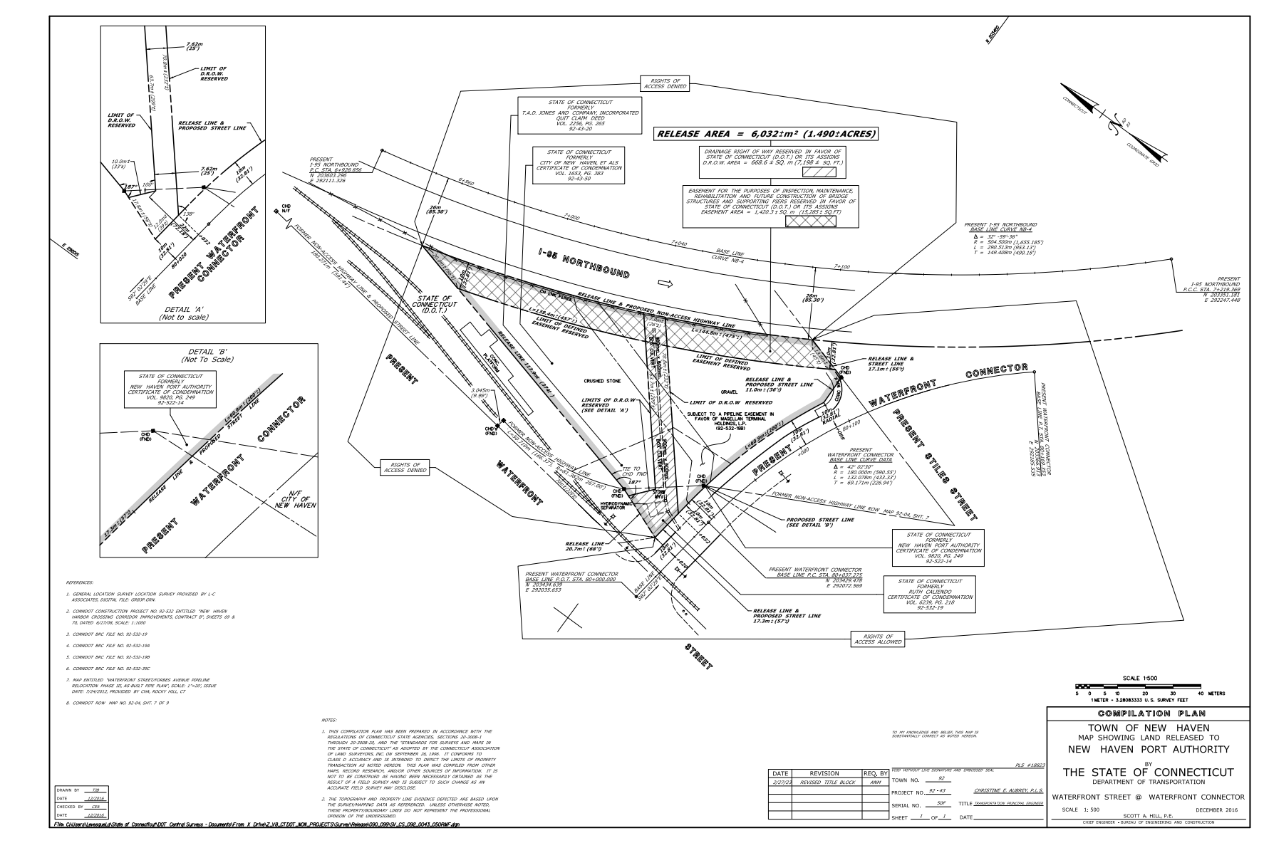
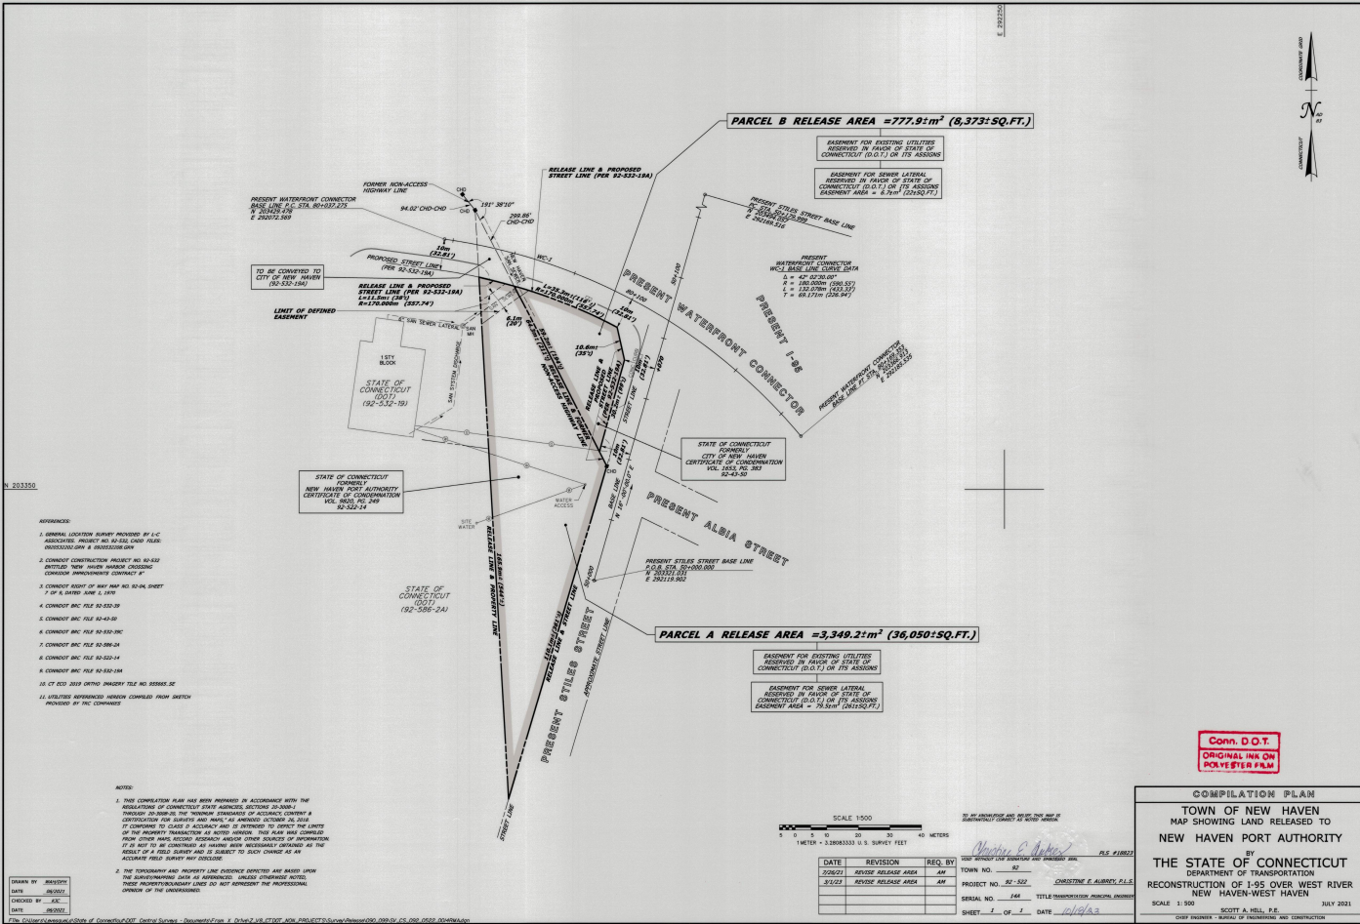
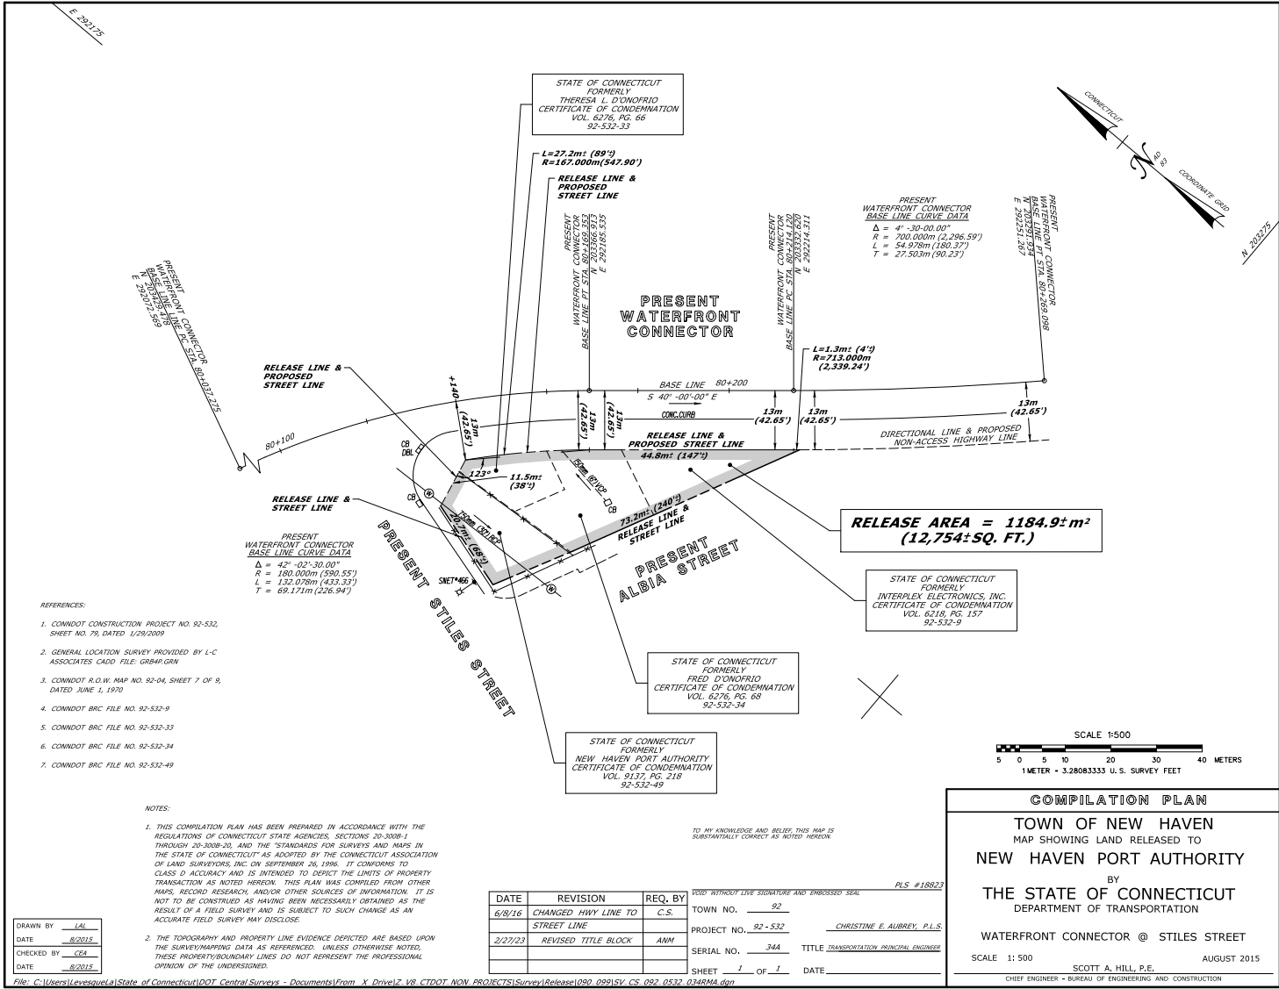
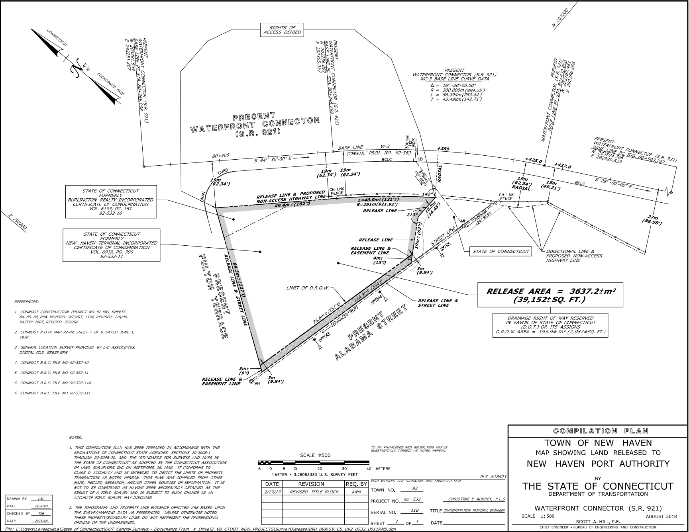

LINKS TO RELEVANT DOCUMENTS

GENERALLY APPLICABLE DOCUMENTS
Anchor File #1 – Summary Report – Parcels 1, 4, 5, 6 – March 2019
https://newhavenct-my.sharepoint.com/personal/portauthority_newhavenct_gov/Documents/Documents/DOT%20Properties/DOT%20Parcels%201.%204.5.%206/Phase%201%20ESAs/Anchor%20Engineering%20-File%20#1 - Summary Report - Parcels 1,4,5,6 - Phase 1.PDF
Appendix C All Eolas Phase 1 Reports – City Directories – March 2022
https://newhavenct-my.sharepoint.com/personal/portauthority_newhavenct_gov/Documents/Documents/DOT%20Properties/DOT%20Parcels%201.%204.5.%206/Phase%201%20ESAs/Appendix%20C%20-%20All%20Eolas%20Phase%201%20Reports%20-%20City%20Directories%20-%20March%202022.pdf
PARCEL 1 REPORTS
Anchor Engineering Preliminary Site Evaluation Parcel 1 File No. 92-43-50E – May 2019
https://newhavenct-my.sharepoint.com/personal/portauthority_newhavenct_gov/Documents/Documents/DOT%20Properties/DOT%20Parcels%201.%204.5.%206/Phase%201%20ESAs/Anchor%20Engineering%20-%20Preliminary%20Site%20Evaluation%20%20Parcel%201%20-%20DOT%20File%20#92-43-50E- May 2019.PDF
Eolas Phase 1 Environmental Site Assessment Report - Parcel 1 - DOT File #92-43-50E – prepared for NHPA - March 2022

https://newhavenct-my.sharepoint.com/personal/portauthority_newhavenct_gov/Documents/Documents/DOT%20Properties/DOT%20Parcels%201.%204.5.%206/Phase%201%20ESAs/Eolas%20Phase%201%20ESA%20Report%20-%20Parcel%201%20-%20DOT%20File%20#92-43-50E - March 2022.pdf

Eolas Phase 2 Subsurface Investigation Report –prepared for NHPA – September 2022

https://newhavenct-my.sharepoint.com/personal/portauthority_newhavenct_gov/Documents/Documents/DOT%20Properties/DOT%20Parcels%201.%204.5.%206/Phase%202%20ESAs/Eolas%20Phase%202%20Subsurface%20Investigation%20Letter%20Report%20-%20Parcel%201%20-%20September%202022.pdf
https://newhavenct-my.sharepoint.com/personal/portauthority_newhavenct_gov/Documents/Documents/DOT%20Properties/DOT%20Parcels%201.%204.5.%206/Phase%202%20ESAs/Eolas%20Phase%202%20Investigation%20-%20figures%20and%20tables%20-%20Parcel%201.pdf

PARCEL 4 REPORTS
Anchor Engineering - Preliminary Site Evaluation - Parcel 4 - DOT File #92-43-34A – prepared for the Connecticut Port Authority – May 2019

https://newhavenct-my.sharepoint.com/personal/portauthority_newhavenct_gov/Documents/Documents/DOT%20Properties/DOT%20Parcels%201.%204.5.%206/Phase%201%20ESAs/Anchor%20Engineering%20-%20Preliminary%20Site%20Evaluation%20Parcel%204%20-%20DOT%20File%20#92-43-34A - May 2019.PDF

Eolas Phase 1 Environmental Site Assessment Report – Parcel 4 - DOT File #92-43-34A - prepared for the NHPA – March 2022

https://newhavenct-my.sharepoint.com/personal/portauthority_newhavenct_gov/Documents/Documents/DOT%20Properties/DOT%20Parcels%201.%204.5.%206/Phase%201%20ESAs/Eolas%20Phase%201%20ESA%20Report%20-%20Parcel%204%20-%20DOT%20File%20#92-43-34A - March 2022.pdf

Eolas Phase 2 Subsurface Investigation Report – Parcel 4 - prepared for NHPA – September 2022

https://newhavenct-my.sharepoint.com/personal/portauthority_newhavenct_gov/Documents/Documents/DOT%20Properties/DOT%20Parcels%201.%204.5.%206/Phase%202%20ESAs/Eolas%20Phase%202%20Subsurface%20Investigation%20Letter%20Report%20-%20Parcel%204%20-%20September%202022.pdf

https://newhavenct-my.sharepoint.com/personal/portauthority_newhavenct_gov/Documents/Documents/DOT%20Properties/DOT%20Parcels%201.%204.5.%206/Phase%202%20ESAs/Eolas%20Phase%202%20investigation%20-%20figures%20and%20tables%20-%20Parcel%204.pdf

PARCEL 5 REPORTS

Anchor Engineering - Preliminary Site Evaluation - Parcel 5 - DOT File #92-43-11B – prepared for the Connecticut Port Authority – May 2019

https://newhavenct-my.sharepoint.com/personal/portauthority_newhavenct_gov/Documents/Documents/DOT%20Properties/DOT%20Parcels%201.%204.5.%206/Phase%201%20ESAs/Anchor%20Engineering%20-%20Preliminary%20Site%20Evaluation%20Parcel%205%20-%20DOT%20File%20#92-43-11B - May 2019.PDF

LES Subsurface Site Investigation Report – WSA pre-existing conditions report – Parcel 5 – prepared for the City of New Haven by Logical Environmental Solutions in March 2020

https://newhavenct-my.sharepoint.com/personal/portauthority_newhavenct_gov/Documents/Documents/DOT%20Properties/DOT%20Parcels%201.%204.5.%206/Phase%202%20ESAs/LES%20Subsurface%20Site%20Investigation%20-%20WSA%20Pre-existing%20Condition%20Survey%20%20-%20Parcel%205%20-%20%20DOT%20File%20#92-532-11B - March 2020.pdf

Eolas Phase 1 Environmental Site Assessment Report – Parcel 5 - DOT File #92-43-11B - prepared for the NHPA – March 2022
https://newhavenct-my.sharepoint.com/personal/portauthority_newhavenct_gov/Documents/Documents/DOT%20Properties/DOT%20Parcels%201.%204.5.%206/Phase%201%20ESAs/Eolas%20Phase%201%20ESA%20Report%20-%20Parcel%205%20-%20DOT%20File%20#92-43-11B - March 2022.pdf

LES Subsurface Site Investigation Report – WSA Post-project conditions report – Parcel 5 – prepared for the City of New Haven by Logical Environmental Solutions in August 2022 and updated May 2023

https://newhavenct-my.sharepoint.com/personal/portauthority_newhavenct_gov/Documents/Documents/DOT%20Properties/DOT%20Parcels%201.%204.5.%206/Phase%202%20ESAs/LES%20Subsurface%20Site%20Investigation%20-%20WSA%20-%20Post-Project%20condition%20survey%20-%20Parcel%20%205%20-DOT%20File%20#92-532-11B - August 2022.pdf

