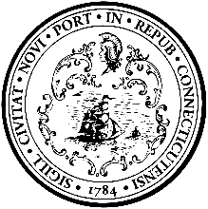
New Haven City Plan Department
165 CHURCH STREET, NEW HAVEN, CT 06510
TEL (203) 946-6378 FAX (203) 946-7815

April 3, 2024
Customer Number: 260951
P.O. 20240116-000

Attention: Kristi Palmiero/ Ethan Swanson Please email proof before printing
New Haven Register: Legal Notices
100 Gando Drive
New Haven, CT 06511

PUBLISH 1 TIME
UNDER NEW HAVEN LEGAL NOTICES:
On April 4, 2024

Please use no color and/or bold text or additional spaces except as shown.

Legal ad begins here
New Haven Historic District Commission. Public Hearing. Wed. April 10, 2024 at 7:00 p.m. The meeting will be held via Zoom. All application materials and meeting link can be found at https://historic-district-commission-1-newhavenct.hub.arcgis.com/ or in the City Plan Department by appointment. 24-02-CA 17 Sea Street. City Point Local Historic District. Owner: New Haven Public Schools. Applicant: Dr. Madeline Negron. Seeking approval to construct an addition to the Sound School.
Legal ad ends here

Fatima Cecunjanin, City Plan Dept. (203) 946-6539 165 Church St, 5th Floor New Haven, CT 06510. fcecunjanin@newhavenct.gov

Note: Please send a tear sheet and an affidavit of publishing date to my attention at the above address.
Please send invoice for notice to Carol Casanova (203-946-6379, CCasanova@newhavenct.gov)

