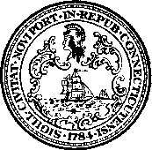
CITY OF NEW HAVEN DEMOCRACY SCHOOL APPLICATION

DUE April 21st
The City of New Haven Democracy School provides a unique opportunity for citizens to learn about City Government and interact with City Hall staff and government officials.

Democracy School will be held on Thursday nights from 6:00 to 8:00PM beginning April 27th and will last 9 weeks including 8 sessions and a final graduation ceremony if conditions permit. Applicants will be notified of acceptance decisions via email by April 24th.

Return your application by April 21st to:
Email: sokonofua@newhavenct.gov – Subject Line: Democracy School

Name:
Mailing Address:
City: | State: | Zip:
Phone Number:
Email Address:

Please respond to the following in the space below:

1. Please describe your occupation (if not working please indicate past occupation):
2. Please describe your present and past community involvement – voluntary, social, other:
3. What would you like to gain from participating in the City of New Haven Democracy School?
4. Would you be interested in serving on a City Board or Commission or running for local office? (For informational purposes. Not a requirement of participation):

If you have any questions contact Sandra Okonofua at 203-464-0021 or sokonofua@newhavenct.gov

